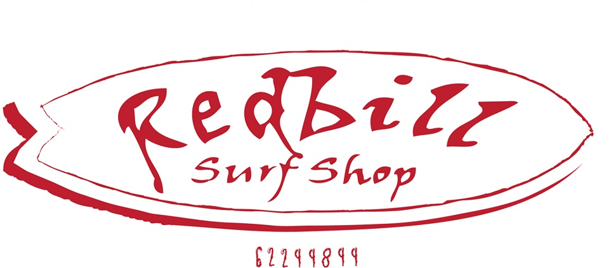

REDBILLS RETURN/ EXCHANGE FORM
Simply fill out your details below, include this page with with your returned items and we will process your request as soon as possible.
Name:______________________________________________________________
Order number:________________________________________________________

QUANTITY | ITEM | COLOUR | REASON FOR RETURN
QUANTITY | ITEM | COLOUR | REASON FOR RETURN
QUANTITY | ITEM | COLOUR | REASON FOR RETURN
QUANTITY | ITEM | COLOUR | REASON FOR RETURN
QUANTITY | ITEM | COLOUR | REASON FOR RETURN
QUANTITY | ITEM | COLOUR | REASON FOR RETURN

ALL RETURNS ADRESSED TO SHOP 63, 29 CHANNEL HIGHWAY KINGSTON TAS 7050

